PAST TAXATION QUESTIONS

**2018 – CALCUALTE THE USC TO BE PAID**

12,012 * .5% 60.06

7,360 * 2% 147.20

40628 * 4.75% 1,929.83 12012 + 7360 = 19372 - 60000

2,137.09 (D)

**2018 – CALCUALTE THE PAYE TO BE PAID**

**GROSS PAY**

55,000 + 5,000 = 60,000 (A)

**PAYE**

34,550 * 20% = 6910

25,450 * 40% = 10180 17090 (60000 – 34500)

Less TC = 1650

1650

70 3370

PAYE 13720 (B)

**2019 – WHAT DO THE FOLLOWING LETTERS STAND FOR**

PAYE Pay AS You Earn

USC Universal Social Charge

PRSI Pay Related Social Insurance

DIRT Deposit Interest Retention Tax

CGT Capital Gains Tax

**2016 – DISTINGUISH BETWENE VAT and COPORATION TAX**

Value Added Tax is a tax on goods and services. It is a tax on spending paid by business and households. The standard rate is 23% but there are various rate depending on the product and service.

Corporation tax is a tax on profits paid by businesses. It is 12.5% in Ireland. This is one of he lowest rate worldwide and is one of the reason to attract FDI

**2018 – CALCUALTE THE PRSI TO BE PAID**

60,000 * 4%

= 2,400 (C)

**2018 – CALCUALTE THE TAKE HOME PAY**

GROSS PAY 60,000

LESS TAX

B 13,720

C 2,400

D 2,137.09 18,257.09

Net Annual Take Hone Pay 36,742.91

**2013 – CALCUALTE AUDREY’S PRSI TO BE PAID**

80,000 * 4%

= 3,200 (C)

**2013 CALCULATE AUDREY’S TAKE HOME PAY**

**GROSS PAY**

78,000 + 2,000 = 80,000 (A)

**PAYE**

32,800 * 20% = 6,560

47,200 * 41% = 19,352 25912 (80000 – 32,800)

Less TC = 1650

1650

320 3,620

PAYE 22,292 (B)

**2015 – WHAT DOES PAYE STAND FOR AND GIVE TWO FEATURES**

PAYE Pay As You Earn

Features

1. Progressive – The more you earn the more you pay
2. Efficient – business collects it for revenue
3. Direct – it is deducted at source
4. Form based

**2013 – CALCUALTE TAUDREY’S USC TO BE PAID**

10,036 * 2% 200.72

5,980 * 4% 239.20

63,984 * 7% 4,578.88 (10,036 + 5,980 = 16,016 – 80,000)

4,918.44 (D)

**2013 – CALCUALTE THE TAKE HOME PAY**

GROSS PAY 80,000

LESS TAX

B 22,292

C 3,200

D 4,918.44 30,410.80

Net Annual Take Hone Pay 47,589.20

**2008 – MANAGING A BUSIESS IS SIMILAR TO MANAGING A HOSEHOLD DISCUSS**

1. Finance

2. Taxation

3. Identify Risk

4. Fill out Forms

5. Keep Forms safe

PAST INSURANCE QUESTIONS

**2016 – Question 4**

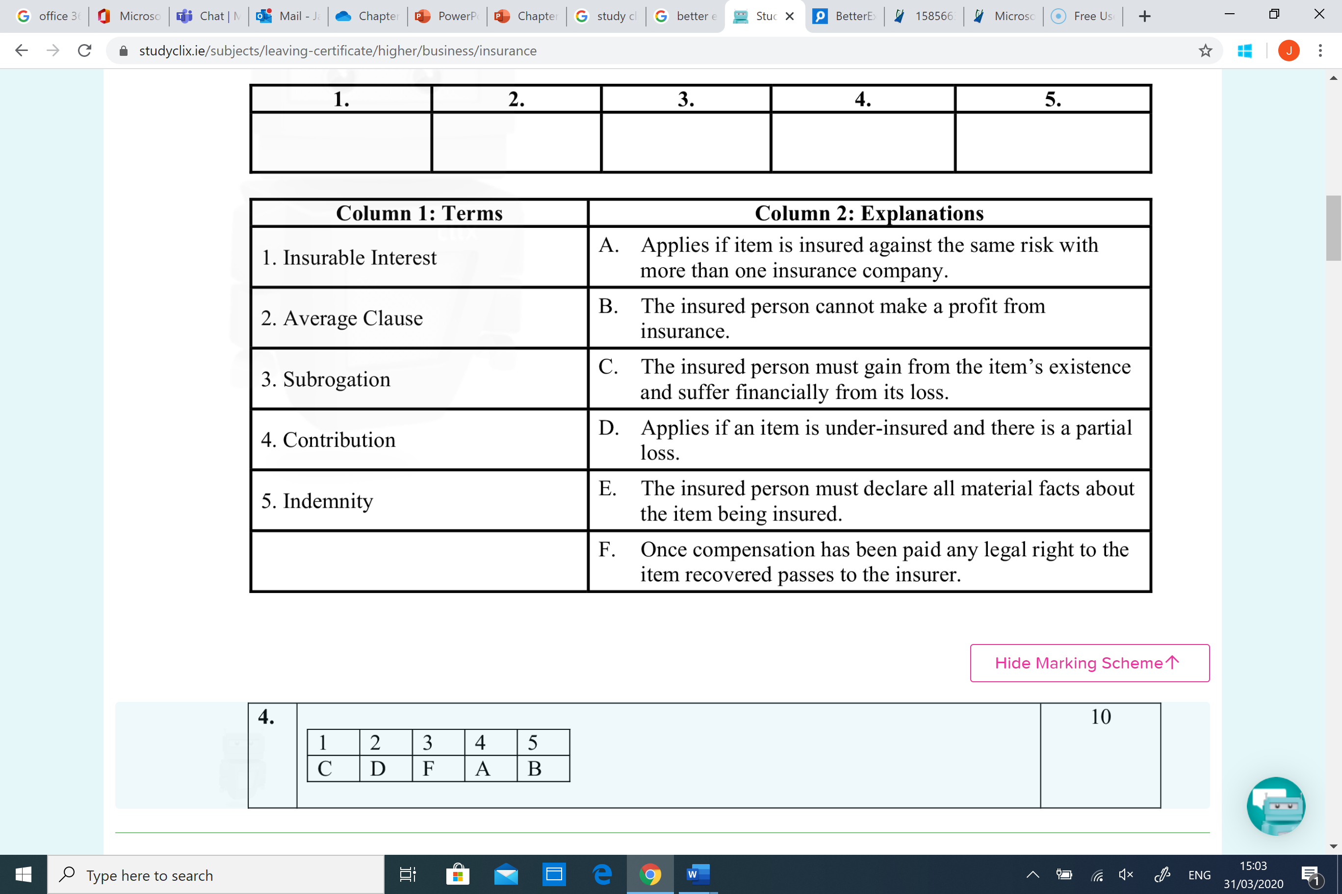1C 2D 3F 4A 5B

**2015 - OUTLINE THE FUNCTION OF AN INSURANCE**

**PROPOSAL FORM.(i)**

1. Insurance Proposal forms are used to apply for insurance cover

and of the risk against which the insurance protection is desired.

2. Insurance Proposal form helps the insurance company to

calculate the premium based on all the potential risks in relation to

the insurance policy.

**2018 - IDENTIFY THE MAIN TYPES OF INSURANCE A BUSIENSS SHOULD HAVE**

**Employers Liability** - protects the business against claims made by employees

**Public Liability** – protects the business against claims made by members of the public

**Product Liability** - insures the business against claims made by customers

**Fidelity Guarantee Insurance** – insurance against fraud, theft or dishonesty of employees

**2015 – EXPLAIN THE PRINCIPLE OF INSURANCE REFERRED**

**TO IN THE EXTRACT (ii)**

**Utmost Good Faith:** All material facts must be revealed. The person taking out the insurance must answer all the questions truthfully. Failure to do so can make the insurance cover worthless. If the insurance contract is obtained by way of fraud or misrepresentation it is void e.g. a driver should declare truthfully the number of penalty points on his licence..

**2008 – OUTLINE TWO OTHER PRINCIPLES OF INSURANCE (iii)**

**Subrogation:** If a third party is responsible for damaging your car in an accident and you are compensated by your own insurer, your insurer can then sue the other driver

**Contribution:** This principle states that if you hold more than one insurer liable for your losses, they have to share the loss.

**2008 – OUTLINE TWO OTHER PRINCIPLES OF INSURANCE (iii)**

**Indemnity:** An insured person cannot make a profit from an insurance claim i.e. insurance can at best put an insured person in the same financial position as they were prior to a loss occurring.

**Insurable Interest:** The insured must gain from the existence of the exposure unit and suffer from its loss. You can insure your own car but not your neighbours.

**2014 – EXPLAIN ‘UNDERINSURED’ AND OUTLINE ONE POSSIBLE EFFECT**

Underinsured means the business has inadequate insurance cover. The insured fails to insure for the full value of the policy. In the event of a claim for total loss may result in economic losses to the policy holder

Result in financial crisis Lower premium

Increase profits

**2009 – DISTINGUISH BETWEEN PUBLIC LIABILITY AND FIDELITY GUARANTEE**

Insurance cover for the business which protects the business

against claims by members of the public for injury or loss

resulting either from an accident on the business

premises (Public Liability)

Insurance cover for the business which protects the

business against financial losses, as a result of theft or fraud by

an employee. (Fidelifty)

**2012 – POSSIBLE BUSINESS RISK AND APPROPRIATE INSURENCE**

1. Risk of structural damage – Building insurance

2. Damage to stock – Contents insurance

3. Involved in a traffic accident – motor insurance

4. Losing an important member of staff – key person insurance

5. Risk of customer injuring themselves – Public liability insurance

6. Risk of worker injuring themselves – Employer Liability insurance

**2008 – EXPLAIN THE TERM RISK MANAGEMENT & METHODS**

A planned approach to the handling of the risk that the individual

or business is exposed to is known as risk management. It involves

Identification of risks cause of loss, likely hood of it occurring

**Insurance:** Transfer the risk to an insurance company

**Safe Procedures:** The manner/act of doing something Strictly

**Training of personnel in health and safety**

**Install Security systems**

**Regular safety inspections/audits.**

**2008 – INSURANCE CALCULATION CLAIMS**

Value insured x Loss = Compensation

Value of House

300,000 x 63,000

35,0000

54,000

Principle of Indemnity.

Taxation

**SUCCESS CTITERIA**

1. Calculate total income (A)
2. Calculate the PAYE –

* multiply the gross income by the lower SRCOP.
* The take the SRCOP away from the total salary and multiply it by the higher SRCOP rate (B)
* Add these two figures together (B)
* Take the tax credit away (B)

1. Calculate the PRSI using gross income multiply by PRSI rate (C)
2. Calculate the USC – using the gross income – use the different rate correctly (D)
3. Add all the taxes together B + C + D and take it away from A

Use the diagram on the left for the layout

**SAMPLE CALCUALTION OF INCOME**

**TYPES OF TAXATION**

Corporation Tax - This is tax paid on profits earned by companies. It is 12.5% which is low for international standards but is needed to attract foreign transnational companies to Ireland. It also provides a incentive for Irish entrepreneurs to take the risk of setting up a company.

Value Added Tax (VAT) - This is a percentage tax that is added to the price of certain goods

and services. Most business except those with very small scale have to register for VAT.

Capital Gains Tax - Tax paid on profits earned from the sale or disposal of a business asset

Customs Duties - Are taxes levied on imports coming into the country from outside the EU

Commercial Rates - These are taxes that are levied by local authorities on properties used for commercial purposes to help finance local government services.

Employer’s PRSI - Is levied on firms for every person that they employ. If funds social welfare such as unemployment payments, pensions maternity benefit. It’s calculated as a percentage of the employee’s gross income

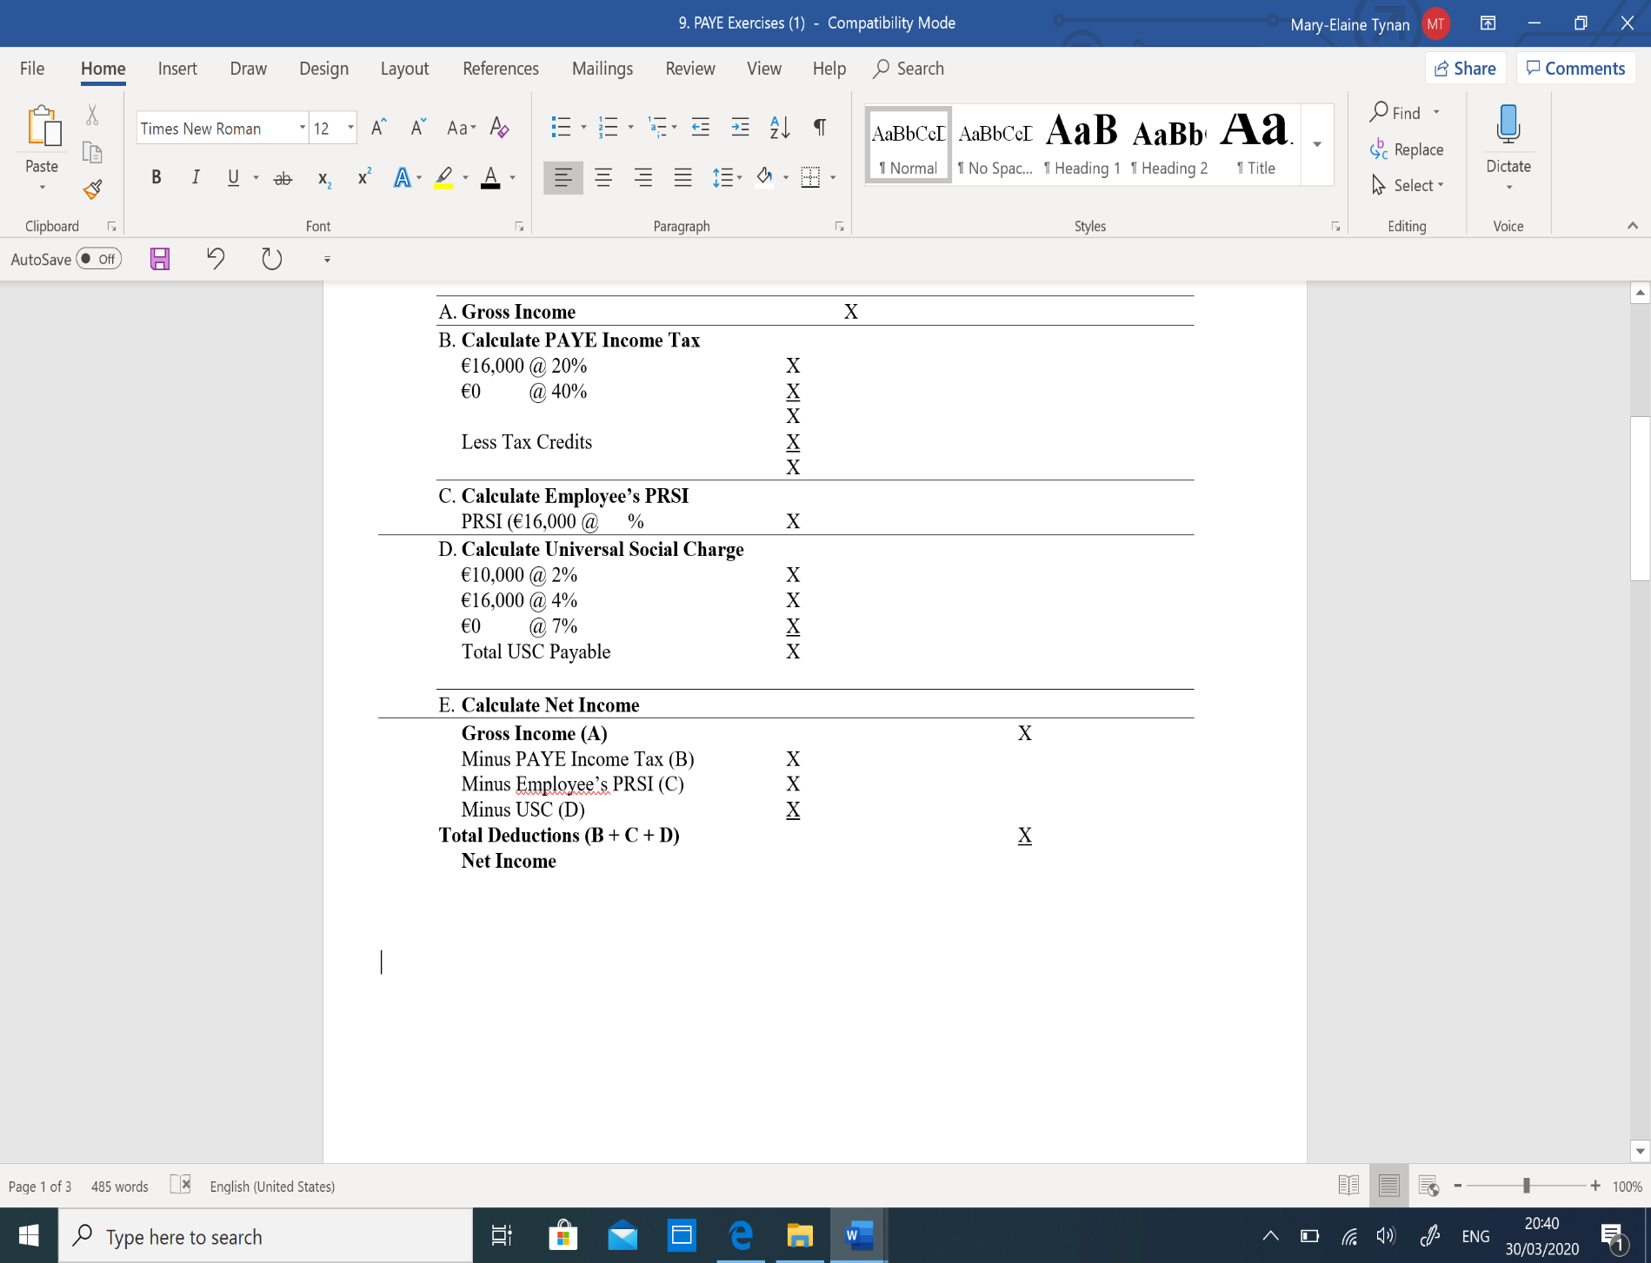

**HOW DOES TAXATION AFFECT BUSINESS**

Lower Profits - Taxes reduce the final profits which in-turn reduce the amount of money that can be reinvest into the business and paid out to shareholders

Higher prices - Taxes such as VAT and customs duties increase the selling price of goods thus reducing profits

Human resources - High taxation of staff can reduce motivation which may result in them looking of higher wages

Incentives - Firms may locate their business in a particular areas or country to take advantage of the tax incentives

**COMPARSION OF HOUSEHOLD AND BUSINESS TAXATION**

|  |  |
| --- | --- |
| **Similarities** | **Difference** |
| Liable – both pay tax | Amount paid |
| Records – both must keep records | Types of Taxes paid |
|  | Tax refund and write off |
|  | Tax collection |

**TAXES PAID BY A BUSINESS**

Pay as you Earn (PAYE)- Income Tax is paid by all employees. All business must deduct PAYE tax form their employee wages before they get paid. This money is then forward onto the Revenue

Self-Assessment Income Tax - This is paid by Sole traders on their incomes. Every year self-employed people must calculate their own tax liability. Random spots checks are carried out by the revenue commissioner to ensure that the correct payment is made

PRSI (Pay Related Social Insurance) - This is a compulsory insurance payment by employees to the state. It is calculate as a percentage of gross income

Universal Social Charge (USC) - This is a tax on gross income and is paid regardless of whether they pay income tax under the PAYE system or self-assessment income.

Excise Duties - These are taxes that are added to the price of certain goods such as alcohol

Motor Tax - This is a tax that must be paid annually on all roadworthy vehicles and is collected by local Authorities

Capital Gain Tax (CGT) Customs Duties -

Capital Acquisition Tax (CAT) Value Added Tax (VAT)

1. DIRT (Deposit Interest Retention Tax)

This is automatically deducted from all interest paid on bank and building society accounts and

passed onto the revenue commissioner

**TAXATION DOCUMENTS**

Tax Credits - This is an allowance form the Government that reduce the amount of tax owed. An employee

they should fill in a Form 12A when they a job for the first time to get the correct tax credits

Form 12A - used by revenue to calculate the rate of tax that will apply to an employee and the tax credits that they are to receive

Notice of credits - This is a document setting out the tax credits and the standard rate of cut of point an employee is entitled to. A copy of this is sent to the employee and employer each year

Form P60 - Employees receive this at the end of each year. It shows the amount of pay, income tax and

PRSI paid by the employee for the year

Form P21 (balancing Statement). This form is sent to the Revenue if they have paid too much tax in a year. If they have they will receive a rebate employer.

P45 (Cessation Certificate) - This is given by the employer to the employee when they leave a job.

Insurance

**KEY WORDS**

***Fidelity Guarantee Insurance*** - This provides business cover against

dishonesty of fraud by an employee against the firm

***Public Liability*** - The cover a business against claim if a member of the public

is injured in an accident that is the fault of the business

***Employer’s Liability*** - Protects a business against claims arising from

accidents, injuries and illness suffered by employees as a result of their work

***Consequential Loss*** - Provides financial compensation for loss of income in

the event of a risk occurring

**Whole life assurance** - the insured pays an annual premium for the rest of

their life and compensation will be paid out when death occurs

**Endowment life assurance** - Under this policy compensation is paid out if you reach a certain age or death occurs which ever happens first

**Term-Life assurance** - this provides cover for an agreed period of time such

as 20 years no lump sum is paid unless death occurs within that period

**Proposal form** - This is an application form which is completed by the person

who is applying for insurance

**Loading** – Extra charge for higher risk - Smoker

**WHAT IS RISK MANAGEMENT**

It is a planned approach to handling the risk that an individual or business is

exposed to. It means identifying key business risks, their likely effect on the

business and then putting in place a strategy to minimise them occurring and

if they do to resolve them as quickly as possible

**STEPS INVOLVED IN BENG INSURED**

1. Contact an insurance company – a Broker or Agent
2. fill in a proposal form – an application from. Identify the item being insured (Exposure unit)
3. Risk in assessed and premium is calculated – fee to be paid is calculated based on level of risk, value, Loading
4. Policy is issued – this sets out what is insured and for how much
5. Make a claim if the insured event occurs – a claim form is fill ed in setting out what happened90-

**METHODS TO REDUCE RISK**

Insurance Safety procedures Safety statement

Training Security Alarms Regular safety Audits

Appoint a health and safety officer

**WHAT IS INSURANCE**

Insurance companies collect premiums from a large number of people. Only a

Small number of these risk will actually happen causing the insurance

company to pay out. This allows the insurance company to pay out

compensation but also have money left over for a profit

**IMPORTANCE OF INSURANCE**

|  |  |
| --- | --- |
| **Business** | **Household** |
| Survival is protected | Financial security |
| Improve Cash flow | Piece of Mind |
| Make exporting easier | Enhanced savings |
| May be a legal reequipment |  |

**PRINCIPAL OF INSURANCE**

|  |  |  |  |  |
| --- | --- | --- | --- | --- |
| **Insurable Interest** | **Utmost Good Faith** | **Indemnity** | **Contribution** | **Subrogation** |
| must benefit for  the existence of the  item being insured  and suffer from the  loss. you can only  claim compensation  on something for  which you have  taken out insurance.  This is known as  Proximate clause. For example, if you insure a business equipment against fire  and it is then stolen the business cannot claim insurance | This is also known as  Uberrima Fidei. It means  that the insured must give  truthful information  and give all relevant facts  when applying for insurance.  A relevant fact is anything  that could influence the  insurer’s decision to take on  the risk and calculate the  premium | The insured can’t  make a profit from  an insurance claim  and no compensation  is paid for  sentimental loss  Life assurance is an exception to the principal of insurance. | This principal states  that if insurance is  taken out with 2  insurance companies,  the insurance  companies will divide  the total cost of the  claim between them.  are not they money will have to be paid back | This principal  states that the  insurers who pay  out full  compensation for  an item insured are  entitle to take  possession of the  item involved and  sue a third party  who caused the loss |

**TYPES OF INSURANCE**

|  |  |
| --- | --- |
| **Business** | **Household** |
| Third part fir and theft | House insurance |
| Comprehensive insurance | Motor Insurance |
| Health Insurance | Mortgage protection insurance |
| PRSI | Permanent Health insurance |
| Key Person Insurance | Personal accident insurance |
| Fidelity guarantee | Whole life insurance |
| Public labiality | Endowment Insurance |
| Employers Liability | Term-life insurance |
| Consequential loss |  |

**WHAT IS INSURANCE**

This rule applies to partial loss when a loss is suffered.

For example - If you insure your house for 25% of the

value of the house then insurance. Company will only pay

you 25% of the loss suffered

Insured value X Damage

Value of the assets

**SIMILARITIES AND DIFFERENCE**

|  |  |
| --- | --- |
| Similarities | Difference |
| Identify risks | More risk |
| Insure against loss | Suffer greater loss |
| Fill out forms | Pay PRSI for employee |
| Keep policies safe | Treat as an Expense |