PAST HUMAN RESOURCE MANAGEMENT QUESTIONS

**2018 - DISCUSS THE ROLE OF THE FOLLOWING PERSON SPECIFICIATION, JOB DESCRIPTION & PANEL INTERVIEW**

**Person Specification** - Sets out the professional qualifications, experience and key characteristics and skills required by the successful candidate. - Allows the business to define the kind of person required

**2018 – DISTINGUISH BETWEEN INDUCTION TRAINING AND STAFF DEVELOPMENT.**

Induction **training** is necessary for **all new employees** demonstrates the requirements of every day technical **operations/work skills** in the business

Staff Development is taken with **existing employees** is focus is on **career development** and **brings all employees to a higher level in terms of their general skills** of leadership, and communication.

**2019 - DISCUSS THE REASONS WHY MANAGEMENT CARRIES OUT PERFORMANCE APPRAISAL.**

1. To review the progress of employees to determine a reward.
2. Goals are set for future performance & targets can be agreed
3. Decide on suitable wages for employees or discuss a pay rise.
4. To provide employees with feedback.
5. To improve staff motivation.
6. To assess employee’s potential for promotion or a bonus

**2016 - BENEFITS OF INTERNAL AND EXTERNAL RECRUITMENT**

Benefits of **external** recruitment

1. **Best candidate** for the job can be recruited

2. **New employee** brings fresh ideas/more open to change.

3. **Wide ranging experience** from previous employment

4. **No existing relationships** in the business – may reduce chance of conflict

**2018 - DISCUSS THE ROLE OF THE FOLLOWING PERSON SPECIFICIATION, JOB DESCRIPTION & PANEL INTERVIEW**

**A job description** - relates directly to the nature of the position itself, rather than the person required to fit it. for example, the main duties, tasks and responsibilities involved in the job

**Panel Interview** - A selection technique used to choose the candidate who closely matches the criteria in the person specification. The candidate is interviewed by a group of interviewers who meet the candidate in order to reduce the effect of a single interviewer’s personal bias

**2016 - BENEFITS OF INTERNAL AND EXTERNAL RECRUITMENT**

Benefits of **internal** recruitment:

1. **Morale improves** in business as staff have greater variety and 2. **Employee’s skills** and attitude to work will be well known

3. **working knowledge** of how firm operates – reduces need for and cost of induction training.

4. **Reduces labour turnover** as the opportunity for promotion.

5. **Less disruption** within the business/vacancy can be filled fast

**2014 – OUTLINE THE STAGES IN A ‘RECRUITMENT AND SELECTION’ PROCESS, USING THE HEADINGS**

External recruitment

This is recruitment for outside the business

The new employee may have skills and experience that

may be required by the business but is not present among

existing staff.

**2014 – OUTLINE THE STAGES IN A ‘RECRUITMENT AND SELECTION’ PROCESS, USING THE HEADINGS**

Internal recruitment

This is recruitment from within the business. The employee is familiar with the culture and work practices of the firm. Training and advertising costs are decreased. Motivation within the workplace improves as recognise the opportunities

**2015 – OUTLINE THE BENEFITS OF PERFORMANCE APPRAISAL FOR EMPLOYEES**

1. Rewards/Monetary and Non Monetary

2. Motivation/Job satisfaction:

3. Training and development

4. Feedback

5. Evaluate the performance

6. Promotional path/Recognition

**2014 – OUTLINE THE STAGES IN A ‘RECRUITMENT AND SELECTION’ PROCESS, USING THE HEADINGS**

A job description

This sets out the purpose of a job. It defines where the job is positioned in the organisation It provides essential information to potential recruits and for recruiting the right kind of person to do the job

**2014 – OUTLINE THE STAGES IN A ‘RECRUITMENT AND SELECTION’ PROCESS, USING THE HEADINGS**

Job Interview

The job interview is used to determine whether the candidate and the job complement each other. It is a process in which a potential employee is evaluated by an employer. The process attempts to determine the candidate’s ability to do the job. Interviews generally take the form of interview panels

**2013 – EXPLAIN THE DIFFERENT TYPES OF FINANCIAL AND NON-FINANCIAL REWARDS**

Financial rewards Non-Financial Rewards

Time Rate Benefit in Kind

Piece Rate Promotion

Bonus Job enrichment

Commissions Flex-time

Profit sharing Job sharing

Employee ownership

PAST HUMAN RESOURCE MANAGEMENT QUESTIONS

**2010 - BENEFITS OF PERFORMANCE APPRAISAL FOR A BUSINESS (ii)**

1. Opportunity to review rewards

2. Increased productivity:

3. Overtime Costs may be reduced

4. Retain the right staff

5. Selection and Training

6. Hidden strengths may be identified

**2010 - EXPLAIN WHAT IS MEANT THE TERM PERFORMANCE APPRAISAL (i)**

Performance appraisal is reviewing the performance of the employees. It is carried out by the HR Manager to evaluate the employee. The HR Manager forms a judgement on a person’s work by reviewing the quality of the work, the progress the person has made. An interview/discussion may take place between the employee and HRM to discuss goal setting targets,

**2011 – (ABQ) EVALUATE THE EFFECTIVENESS OF THE HUMAN RESOURCE DEPARTMENT**

Manpower Planning

Recruitment/Selection

Training/Development

Performance Appraisal

Rewarding

**2008 – EXPLAIN THE FUNCTIONS UNDERLINED**

Performance Appraisal

This is the process of reviewing the performance of an employee. Performance appraisal of staff in an organisation requires the Human Resource Manager to form a judgement on a person's work by reviewing the quality of the work, the progress the person has made or the capability of the person.

**2008 – EXPLAIN THE FUNCTIONS UNDERLINED**

Employer and Employee Relationships

The quality of the relationship that exists between employers and employees determines the quality of industrial relations between the parties. The implementation of the various health, safety and welfare regulations in the workplace together with interest in, and support for, the social and recreational needs of employees,

**2008 – EXPLAIN THE FUNCTIONS UNDERLINED**

Training & Development

involves supplying the skills, knowledge and attitudes needed by employees to do their jobs. On arrival new staff receives induction training, on-the-job training, and off-the-job training.

Staff development involves preparing the employees to take on more responsibility and new challenges in the workforce.

**2008 – TWO BENEFITS OF THE UNDERLINED WORDS**

Performance Appraisal

1. Determines suitable pay levels.

2. Selecting suitable candidates for promotion

3. Monitors & controls recruitment, selection, training & development

4. Feedback is received on how people are doing their work

5. Weak areas are identified so that performance can be improved

6. Provides for two-way communication and clarification

g programmes.

**2008 – TWO BENEFITS OF THE UNDERLINED WORDS**

Employer and Employee Relationships

1. Employees are motivated to work to the best of their ability.

2. All personnel are working towards the same goal.

3. Flexibility is increased.

4. Lines of communication are open and clear.

**2008 – TWO BENEFITS OF THE UNDERLINED WORDS**

Training & Development

1. Better quality service to customers less in fewer complaints.

2. Improved quality of production.

3. Staff is better cared for and well motivated

4. Lower labour turnover rates due to high staff morale

5. Flexible and adaptable labour force allowing for changes to take place

**2003 – OUTLINE THE FUNCTION OF THE HR MANAGER**

1. Manpower planning

2. Recruitment and selection

3. Training and Development

4. Performance and appraisal

5. Industrial Relations

**2005– (ABQ) EVALUATE TOM’S EFFECTIVENESS AS A HR MANAGER**

1. Manpower planning

2. Recruitment and selection

3. Training and Development

4. Performance and appraisal

5. Industrial Relations

**HUMAN RESOURCE MANAGMENT**

**KEYWORDS**

**Bonus payments** - give employees a share of the profits resulting from their increase efforts

**Commission** - is an extra payment based on a percentage of the value of sales achieved

**Benefits-in-kind -** These are taxable non-cash payments to staff. It includesFree or subsidised mealsorCompany car

**Profit-sharing schemes -** This is when the firm shares part of their profits with the employees through the payments in addition wages through

**Share ownership schemes** - This is when the company offers free or low-price shares to their employees (Facebook). It is an incentive for staff to keep costs down. It breaks down ‘them and us’ mentality between employees and management

**Industrial Relations** - refers to the quality of the relations between the owners and the employees.

**KEYWORDS**

**job description -** This describes the vacancy that needs to be filled including Title conditions, Duties, Responsibilities, Place of work and Supervision and assessment arrangements

***Person Specification -*** This describes the qualities required by the person who will fill the job description. They include some of the following Academic qualifications, Work experience, Level of physical fitness, Language skills

**Internal Recruitment** - This is using internal communication such as Notice boards, E-mail, Company newsletters to advertise vacancy. This can mean promoting or deploying existing staff from within the business

**External Recruitment -** This involves inviting applicants from outside the business. This can be done by Personal friends, Internet, Newspapers, Employment agencies.

**Curriculum Vitae (CV)** - This is a short document usually 2 pages summarising Personal details, Education, Qualification, Work Experience, Interest and hobbies, Referees

**Induction** - This is the introduction of new staff into a job and an organization. Effective induction should familiarize staff with issues such as - The organization policies and rules,

**Staff Training -** This ensures that all employees have up to date skills and knowledge needed to do their job. This can be done byOn the job andOff the Job –

**Staff Development -**This teaches an employee multiple skill which they can use in many jobs. Itmeans that staff are more flexible and better able to adapt to change (filling in for absent work mates). Are more suitable for promotion – because they have a wider understanding of the different work that is done in the business

**Performance appraisal -** This is the process of setting performance standards for each employee and then assessing their performance regularly over a period of time

**Flat rate pay-** Employees receive an agreed set rate of pay per week/month based on a standard number of hours worked (€500). There is no incentive to work harder or for longer.

**Time-Rate Pay** - Employees are paid a set amount for each hour they work. Overtime is usually paid at a higher rate

There is no reward for improved efficiency and employees may be tempted to work slower so they will receive more payment

**Piece-Rate pay -** Employees are paid for each item produced that meets the desired quality standard. It encourages maxiamum effort. Safety rules may be ignored if workers rush their work. Piece rate is not suitable for certain jobs (Teacher)

**HRM MANAGMENT**

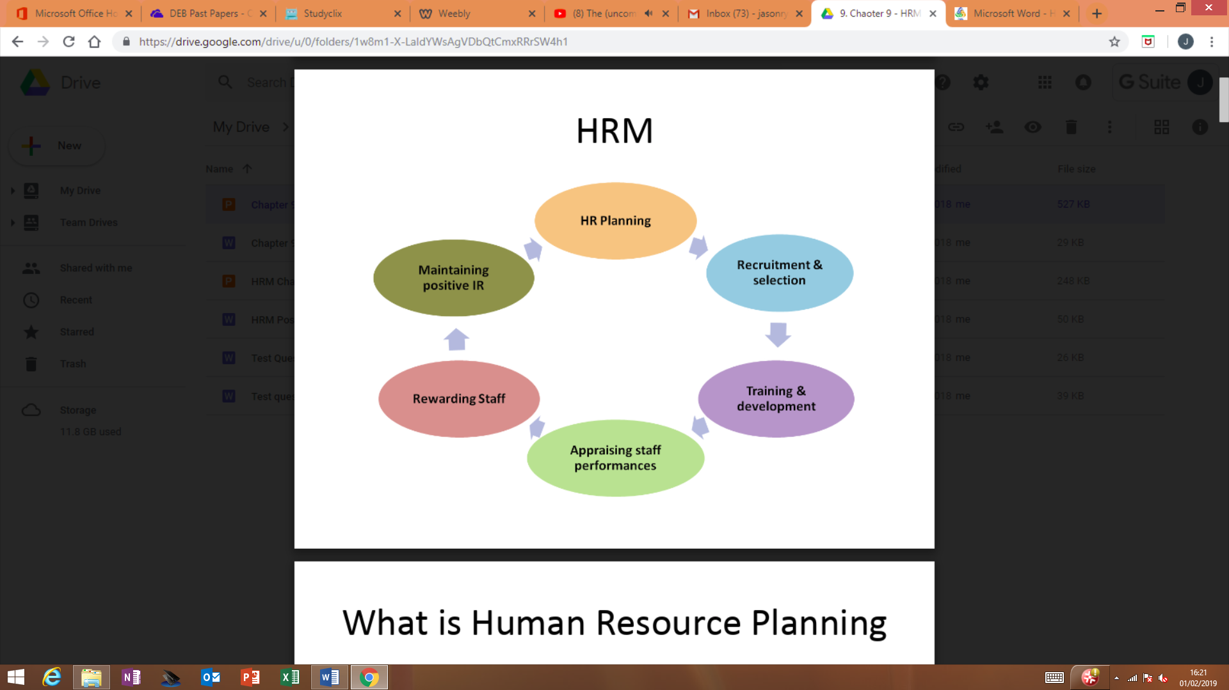

**TRAINING AND DEVLOPMENT**

Usually completed by

1. Induction
2. Staff Training
3. Staff Development

**HR PLANNING**

To prepare a HRP plan the following steps must be followed

1. Audit the present human resource levels
2. Forecast future human resources needs of the business
3. Monitor the level or labour turnover
4. Prepare a HR Plan

**PERFORMANCE APPRAISAL**

This is the process of setting performance standards for each employee and then assessing their performance regularly over a period of time. It involves the following

1. Agreeing targets
2. Reviewing progress
3. Discussing outcomes
4. Identifying any training needs
5. identifying employees for promotion
6. Improving communication

Importance of Performance Appraisals

1. Identify training needs of employees
2. Identify employees who are suitable for promotion
3. Help in deciding pay raises and bonuses
4. Improve communication

**RECURITMENT AND SELECTION**

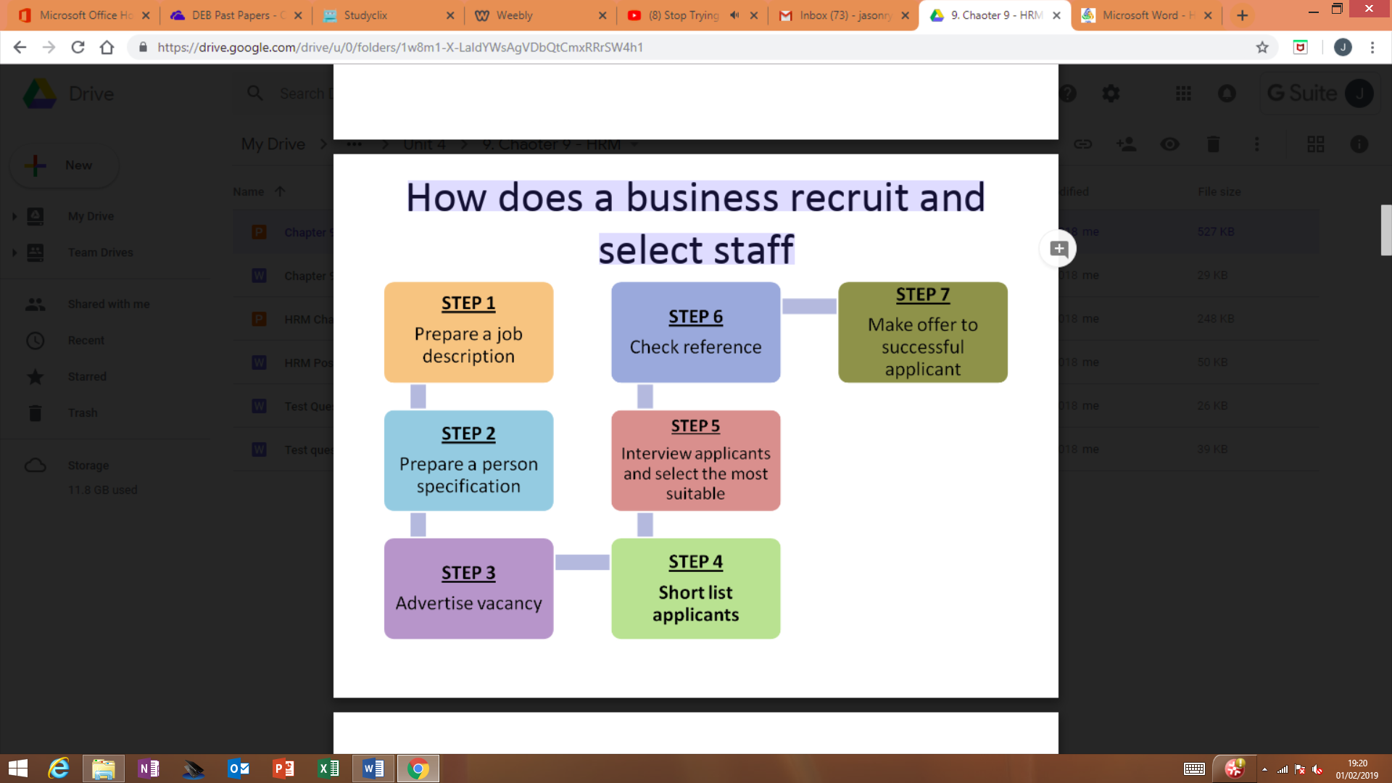

**HUMAN RESOURCE MANAGEMENT**

**INDUSTRIAL RELTIONS**

**Promoting Positive IR**

1. Train managers to deal with human resources problems so they can resolve them quickly
2. Recruit staff with positive attitude and provide proper training and development
3. Communicate regularly and honestly with staff
4. Have a clear grievance procedure for staff and management to follow when conflict arises
5. Train managers to deal with human resources problems so they can resolve them quickly
6. Recruit staff with positive attitude and provide proper training and development
7. Communicate regularly and honestly with staff
8. Have a clear grievance procedure for staff and management to follow when conflict arises

Good IR is important because

1. Improves morale and motivation
2. Productivity is increases
3. Less risk of strikes
4. Reduction in labour turnover

**REWARDING STAFF**

|  |  |
| --- | --- |
| **Financial** | **Non - Financial** |
| Flat Rate Pay | Improve working conditions |
| Time Rate Pay | Shorter working hours/longer holidays |
| Piece Rate Pay | Les stressful work |
| Bonus Pay | Safe working environment |
| Commissions | Flexible working arrangements |
| Benefit in Kind | Job enlargement – variety |
| Profit sharing options | Job enrichment (More responsibility) |
| Share ownership schemes |  |

**FINANICAL REMUMERATION**

Some jobs can be better paid then other for the following reasons

**Demand excess supply** – highly skilled doctors are in smaller supply than bus drivers. So doctors earn more

**Ability and skills** – are required for some jobs

**Long training periods** – Vets and surgeons discourage people so keep the supply down

**The risk, danger and responsibility**