PAST MANAGEMENT SKILLS QUESTIONS

**2016 EVALUATE HOW DIFFERENT PLANS CONTRIBUTE TO BUSINESS SUCCESS**

**Strategic** – Long term 5 years, Provide a guide, prepared by

senior management (long term existence)

**Tactical** – short term 2 years, achieve strategic plans which is

broken down into manageable plans

**Operational** – Daily weekly monthly plans,

**Mission statement** – vision, outline the purpose of the business

**2018 – CONTIGENCY PLAN & IMPORTANCE OF PLANNING**

**Strategic** – Long Term, prepare by senior management, involve

mission Statement,

**Tactical** – Strategic plan broken down, middle management,

make strategic plan possible

**Manpower** – HR resources, no. of staff required, right no. of

people in the right place at the right time with the right skills to

achieve goals

**2018 – IMPLICATION FORM CHANGING FROM FUNCTIONAL TO A MATRIX STRUCTURE**

1. Training required
2. Duplication of Duties
3. Greater complexity in the chain of command (2 Manager)
4. Staff conflicts
5. Increased intrapreneurship
6. Better Staff Relations

**2015 (ABQ) – DEFINE THE TERM PLANNING, EXPLAIN SWOT (CONDUCT A SWOT)**

This Involves selecting organisational goals and finding ways to

achieve them. It important because it Means deciding on 1. Who

will do what, 2. When it will be done and 3. How it will be done?

Strength – Internal, advantage Weakness – Internal, does

Over competition poorly, needs improvement

Opportunities – External, should Threats - External

Be exploited Defended against

**2015 – EXPLAIN THE TERM SPAN OF CONTROL & WHERE A NARROW SPAN OF CONTROL MAY BE APPROPRIATE**

This is the number of employees that report directly to a manager in a hierarchy

It would suit when the work involves a high level of expertise or where worker lack experience

**2015 – OUTLINE THE BENEFITS OF A FUNCTIONAL ORGANISATION STRUCTURE**

**Specialisation** – each department concentrate on one function

**Efficiencies** – things get done quickly and to a high standard

**Chain of command** – Clear line of authority & who to report to

**Clear communication channels** – Upward, downward and horizontal

**Economics of Scale** – Wide span of control

**Clear Promotional Paths**

**2012 – DEFINE THE TERM DELEGATION & BENEFITS OF DELEGATION**

Involves assigning of authority and power to another person. It is

usually from a manager to an employee to undertake a specific

piece of work. The accountability is also assigned

1.Manager has mor time for strategic planning

2.Project completed to a higher level (Accountability)

3.Increased employee motivation

4.Higher skilled workforce

**2013 – DISCUSS THE IMPORTANCE OF PLANNING**

1.Set out specific goals and objectives

2.Reduces risk of uncertainty

3.Conduct a SWOT analysis

4.Develops a Mission statement

5.Strategic Planning

6.Tactical Planning

7.Contingency Planning

**2013 – BENEFITS OF A MATRIX STRUCTURE**

Benefits Challenges

1.Expertise from different 1.Conflict nad personality

Departments Classes (Storming)

2.Input into decision making 2.Two Managers

3.Carry out specific projects 3.Slow Decisions -agreement

4.Support of Project leader 4.Need to improve

5.Greater Job Satisfaction Communication Skills

**2012 – FEATURES OF A MATRIX STRUCTURE**

1.Team based – Expertise from each department

2.Project Leader – Members are answerable to the project leader

3.Specific Projects – Used for development of new project

4.Decision making – All member are involved in the decision making

5.Synergy-

6.Two managers – Team leader and department manager

7.Sharing of resources – Employees and equipment are shared

**2011 – EXPLAIN THE TERM SPAN OF CONTROL & FACTORS AFFECT THE WIDTH**

This refers to the number of employees reporting directly to a manager in a hierarchy

Skill of a manger – Confident manger can have a wide span

Skill of workforce – Trusted motivate employees = wide span

Type of product/service – if work needs high level of expertise narrow span is used

**2012 – DEFINE THE TERM DELEGATION & BENEFITS OF DELEGATION**

Involves assigning of authority and power to another person. It is

usually from a manager to an employee to undertake a specific

piece of work. The accountability is also assigned

1.Manager has mor time for strategic planning

2.Project completed to a higher level (Accountability)

3.Increased employee motivation

4.Higher skilled workforce

PAST MANAGEMENT SKILLS QUESTIONS

**2009 – EXPLAIN THE TERM DELEGATION AND THE**

**BENEFIT TO A MANAGER**

Involves assigning of authority and power to another person. It is

usually from a manager to an employee to undertake a specific

piece of work. The accountability is also assigned. Manager must

make sure that the employee has the skills

1. Completed to a higher standard 2.Increased motivation

3.Manager can priorities tasks 4.Less Stress

**2009 (ABQ) – DISCUSS THREE TYPES OF CONTROL**

Stock

Credit

Quality

Financial

**2010 – ANALYSE THE CONTRIBUTION STRATEGIC AND TATICAL PLANNING MAKES TOA BUSIENSS**

**Strategic**  **Tactical**

1.Long term senior management 1.Short term middle Mgt.

2.Define the business purpose 2.Deal with the now

3.Benchmarking 3.Outline a set of actions

4.Identify Opportunities 4.Helps achieve objectives

**2008 – DISTINGUISH BETWEEN STRATEGIC AND TACTICAL PLANNING**

Strategic – Developed for the long term over 5 years,

Emphasis is on growth drawn up by top management

Tactical – Short term plans over 2 years, relates to a particular function, drawn up by middle management

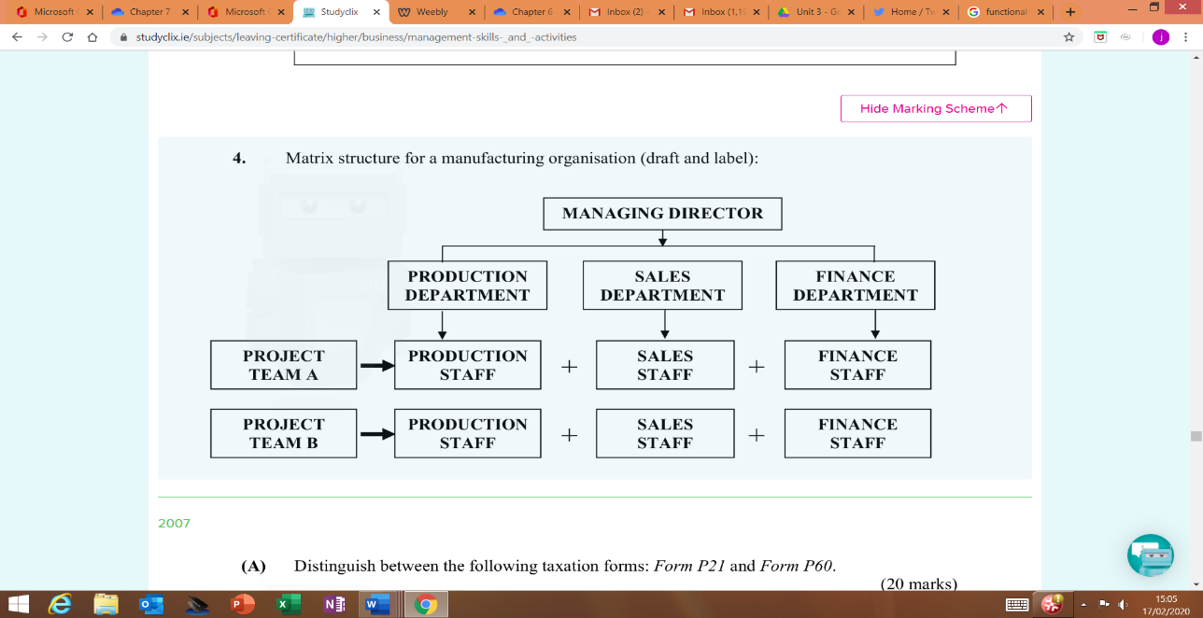

**2006 (ABQ) – DISCUSS MAAGEMENT ACTIVITIES**

**Planning** – Selecting goals and objectives and ways to achieve them. Helps reduce risk and uncertainty. May included strategic, Tactical and operational

**Organising** – This getting thing done through an organised structure that a business can achieve its goals For example functional and matrix

**Controlling** – Involves measure the errors in plans and taking action to correct them -for example stock, Credit

**2007 – DRAFT AND LABEL A MATRIX STRUCTURE**

**2005 – DRAW AND SUITLABLE A SUITABLE ORGANISATIONAL STRUCTURE**

Benefits Challenges

1.Expertise from different 1.Conflict nad personality

Departments Classes (Storming)

2.Input into decision making 2.Two Managers

3.Carry out specific projects 3.Slow Decisions -agreement

4.Support of Project leader 4.Need to improve

5.Greater Job Satisfaction Communication Skills

**2004 – DEFINE ORGANISAING AND ITS IMPORTANCE**

Organising is bringing people and resources together to achieve a

common objective. This is done by building a structure or

organisational chart

1. Creates a suitable organising structure
2. Establishes a chain of command
3. Smooth flow of communication

**2004 – REASON TO CHANGE AN ORGANISATION STRUCTURE**

1.Size – The Business has grown, more expertise needed

2.Limited Liability –

3.Finance – help to raise more capital

4.Marketing – Expansion

5.Opportunity – Diversify into other markets

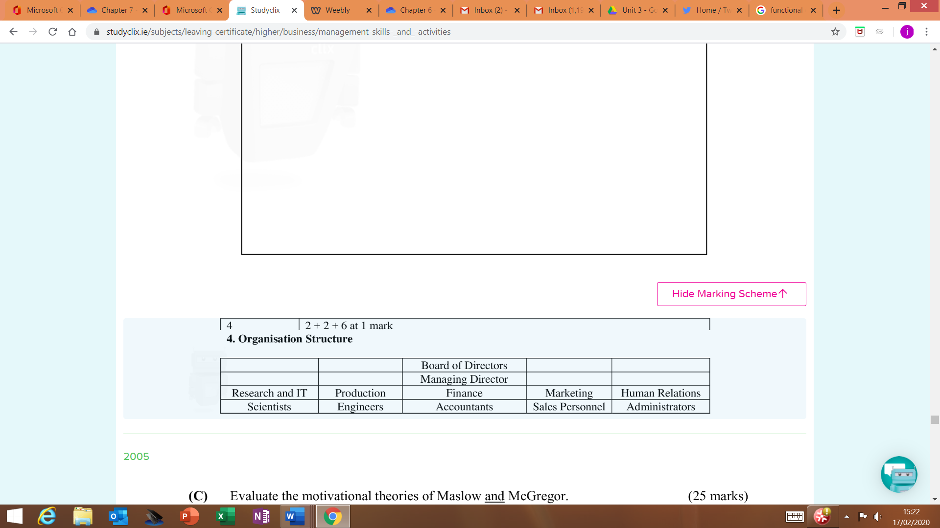

**2012 – FEATURES OF A MATRIX STRUCTURE**

1.Team based – Expertise from each department

2.Project Leader – Members are answerable to the project leader

3.Specific Projects – Used for development of new project

4.Decision making – All member are involved in the decision making

5.Synergy-

6.Two managers – Team leader and department manager

7.Sharing of resources – Employees and equipment are shared

**2012 – DEFINE THE TERM DELEGATION & BENEFITS OF DELEGATION**

Involves assigning of authority and power to another person. It is

usually from a manager to an employee to undertake a specific

piece of work. The accountability is also assigned

1.Manager has mor time for strategic planning

2.Project completed to a higher level (Accountability)

3.Increased employee motivation

4.Higher skilled workforce

**2011 – EXPLAIN THE TERM SPAN OF CONTROL & FACTORS AFFECT THE WIDTH**

This refers to the number of employees reporting directly to a manager in a hierarchy

Skill of a manger – Confident manger can have a wide span

Skill of workforce – Trusted motivate employees = wide span

Type of product/service – if work needs high level of expertise narrow span is used

CONTROLLING

**Key Words**

**Control -** This refers to the monitoring and checking of results to see that they agree with the

targets set out in the plan. It is the continuous monitoring to make sure goals and target will be

meet

**Stock Control** - This is making sure that the firms has the right quantityand type of goods in

stock at the right time without incurring stockholding costs such as insurance, security and rent

**Buffer stock** - This refers to the minimum level of stock that should be held once stock falls

below this level more stock should be ordered.

**Just in Time** - This is a type of stock control system in which stocks of raw materials or

finished products are delivered when they are just needed and no sooner

**Quality Control** -This Means that the quality standards expected by customers are meet

**Quality Circles** - These are discussion groups made up of employees who meet regularly to

discuss and resolve quality issues

**Financial Control** - This is used to monitor the financial affairs of the business to ensure it is

profitable and always has enough money to pay its bills

**Credit** - This Credit means selling goods now but being paid form them later.

**Credit control** - This tries to minimum the risk of bad debts form customers who can’t pay. It

means monitoring which customer are given credit and for how long.

**Credit Controller** - This is the person responsible for managing credit given to debtors and

collecting payment on time.

**Bad Debts** - These are the customers who bought on credit but and not able to pay their bill.

They may be bankrupt.

**Credit**

How to improve Credit Control

1.Offering discounts

2.Take out insurance against bad debts

3.Researching credit background of customers

4.Refusing to give credit

**Stock**

Proper stock control can lead to the 1.Improved profitability – less errors

2.Improved cash flow – Receive payment on time

3.Frees up storage space – raw material when needed

**Financial**

Good control can be achieve by

1.Cash flow budgets – monitor income and expenses

2.Ratio analysis – monitor financial performances

**Quality**

Important for

1.Reduce waste and costs

2.Increase customer satisfaction

3.Help promote a quality image

4.Meet legal responsibilities

Achieved by

1.Regular inspections of goods (random, 100% , Continuous Sampling)

2.Recruiting and training

3.Facilitating teamwork

4.Quality circles

3.Cost control – cost do not rise above a certain level

4.Break even analysis – The min level of sales to make a profit

**Importance of Control**

1. **Correction:** A good control system allows management to detect and correct problems before they get out of control. If Barings Bank had better control systems; Nick Leeson would not have been able to bankrupt the company.
2. **Quality:** The control system will ensure service to the customer’s remains at the highest level. This may be achieved by creating a total quality management system in the organisation and by the introduction of quality awards.
3. **Efficiency:** Waste is reduced in all areas of the organisation when corrective action is prompt.
4. **Profits:** Profits should increase due to a reduction in costs associated with waste and defective products. Sales revenue may increase due to the ability to charge a premium price for a high-quality product.
5. **Keeps bad debts to a minimum**
6. **Control:** It controls and reduce waste and identifies is they are on target or deviating from the plans. The tighter the control the less likely there is for serious errors

ORGANISING

**Key Words**

**Organising -** This Means bringing people and resources together to achieve a common objective.

**Organising Structures -** This means identifying the different departments and management functions in

an organisation.

**Functional structure** - This divides a business according to management functions at senior, middle

management and junior levels. It is the simplest organisation chart

**Product structure** - This organises a business on the basis of the product it makes. Each product has its

own set of specialist management functions

**Geographical Structure** - This is where the organisation is divided according to the geographical markets it serves

**Matrix structure** - This is when staff are brought together into teams to achieve a clearly stated team

goals – launching a new product. Teams are made up of staff with skills in different specialist areas.

**Organisational Chart** - This are diagrams that visually communicate the type of organisation structure,

the chain of command and the span of control in an origination

**Chain of Command** - This is how decision flow from the top of an organisational down through the layers to

the bottom

**The Span of Control** - This refers to the number of employees reporting directly to a manager in a

hierarchy

**De-layering** - This refers to the reduction in the number of layers in the management structure of the

organisation.

**Delegation** – Involves assigning of authority and power to another person. It is usually from a manager to

an employee to undertake a specific piece of work. The accountability is also assigned

an employee to undertake a specific piece of work The accountability is also assigned

**Functional**

1. There are different layers of management in this chart: top, middle, and junior management.
2. It indicates where authority and responsibility have been delegated.
3. It illustrates the chain of command, i.e., who is answerable to whom.
4. It shows the managing director's span of control (the number of people reporting directly to a

manager).

*Advantages* *Disadvantages*

1. Builds staff skills 1. Focus on department gold and not the business

2. Clear promotional paths 2. Communication between department can be slow

**Product**

*Advantages* *Disadvantages*

1. Improve communication 1. Duplication of resources

2. Products Adapt to customer needs 2. Wasteful competition for same customers

3. Each division focus on customer needs



**Geographical**

*Advantages* *Disadvantages*

1. Meet local needs 1. Duplication of resources

2. Encourages competition

**Matrix**

The main characteristics of a matrix structure are 1. They are Self-managed 2. Responsibilities Delegated

and Input into decision making

*Advantages* *Disadvantages*

1. Synergy 1. Two bosses

2. Efficiencies 2. Training costs

3. Better Relations

4. Motivation

**Factors that influence the choice of organisation structure**

1. As simple as possible
2. Allow east communication
3. Use a narrow span of control (important jobs, tight control)
4. Use a wide span of control – to encourage staff empowerment, intrapreneurship and

creativity

1. Be cost effective

**Purpose of an Organisational Chart**

An organisational char shows the following

1. Chain of command
2. Span of Control

A wide span of control means that the manager has a lot of worker (Subordinates) reporting to him. This

give less layers in the company and more effective communication.

A Narrow span of control means that the manager has few workers (Subordinates) reporting to him.

This give more layers in the company and less effective communication.

**Importance of Organising**

Organisation is important because of the following

1. Creates a suitable organising structure
2. Establishes a chain of command
3. Smooth flow of communication

**Key Words**

**Planning** *-* This Involves selecting organisational goals and finding ways to achieve them. It important because it

Means deciding on 1. Who will do what, 2. When it will be done and 3. How it will be done?

**Mission Statement** - These are short but precise one or two sentences statements used by companies to

summarise ‘Who we are, what we do and were we are headed’

**Strategic Plan -** These are long term plans and are usually over 5 years. They are more precise, For

Example, a method of increasing profit over first 10 months of the year.

**Tactical plans**- These are shorter plans operational plans. It breaks up the strategic plan into more manageable

smaller plans. They usually last for 1 -2 years. For Example, company launching a new product, Cadbury’s

launching new white chocolate flake.

**Operational Plans** *-* This is Short term plans which are designed to meet specific objectives. They usually set

out target for weeks or months ahead. A firm introducing a new internal telephone system.

**Business Plans -** This is a document that sets out who is setting up the business, what they will be selling or

producing, how will it be produces and promoted, where the finance will come from and how much profits they

expect to make.

**Contingency Plan** - This is a Plan B. They are special pans to cope with emergencies. It is used if something is

stopping the main plan being implements. For example, the main supplier of your raw material can’t supply the

material that you want.

**Qualities of a good plan**

**Specific** - This means that the plan must be precise about what has to be done who is going to do it and how it will

be done

**Measurable** - This means that it must be easy to measure if you are achieving the objectives of the plan

**Agreed/Achievable** - The plan should be agreed by all in the business

**Realistic** - It must be possible to achieve the objectives and not too far-fetched.

**Timed** - Time must be given to implement the plan

**Why planning is important**

1. Helps identify internal strengths, internal weakness, new opportunities

And identify treats

1. Set out clear targets
2. Assists leadership and motivation (gives direction and purpose)
3. Provides necessary information to investors

Types of Plans

Planning process

**Benefits of planning**

**Direction:** The plan sets the direction for the business by clearly identifying the objectives, e.g., to expand (Ryanair has announced plans to open up new routes and to buy new jets).

**Coordination:** The plan is used to coordinate the activities of the different departments, e.g., the sales department must not take orders that the production department is unable to meet.

**Control:** Management can compare the actual results to the planned targets. Good performance can be rewarded (bonuses) and failure to meet targets should be investigated.

**Finance:** A plan can be used when approaching potential investors for money as it demonstrates how the money will be used and how funds will be generated for repayment.

**Awareness:** An organisation that plans by consulting all relevant stakeholders becomes aware of its Strengths, Weaknesses, Opportunities and Threats (SWOT) and is therefore more adaptable to change.

PLANNING