**Resolving**

*Non-legislative*

1. Meet and negotiate
2. Write a letter of complaint
3. Third part intervention

**Complaints**

Legislative

1. CCPC
2. Office of the ombudsman
3. Small Claim court - This court deals with claims up to €2000. It cost €18 to bring a case here but you don’t have to hire a solicitor.

***Consumer and Competition Protection Commission (CCPC)***

This agency has the following functions

1. To promote and Protec the Interest of consumers
2. To enforce consumer law
3. To investigate an offence that business make under the legislation
4. They advise business in how to implement the law
5. The also give advice to decision makers and make proposal for new legislations

**Consumer Protection Act 2007**

Remedies

Repair – To get the fault fixed by the business. The consumer also has the right to a full refund it the repair is not satisfactory

Replacement – It the fault is more serious then the consumer is entitled to get a new product

Refund – If the goods are not of merchantable quality, as describes, fit for purpose or as described the consumer is entitle to a full refund not just repair or replacement

**Sale of Goods and Supply of Services act 1980**

**Law of the Contract**

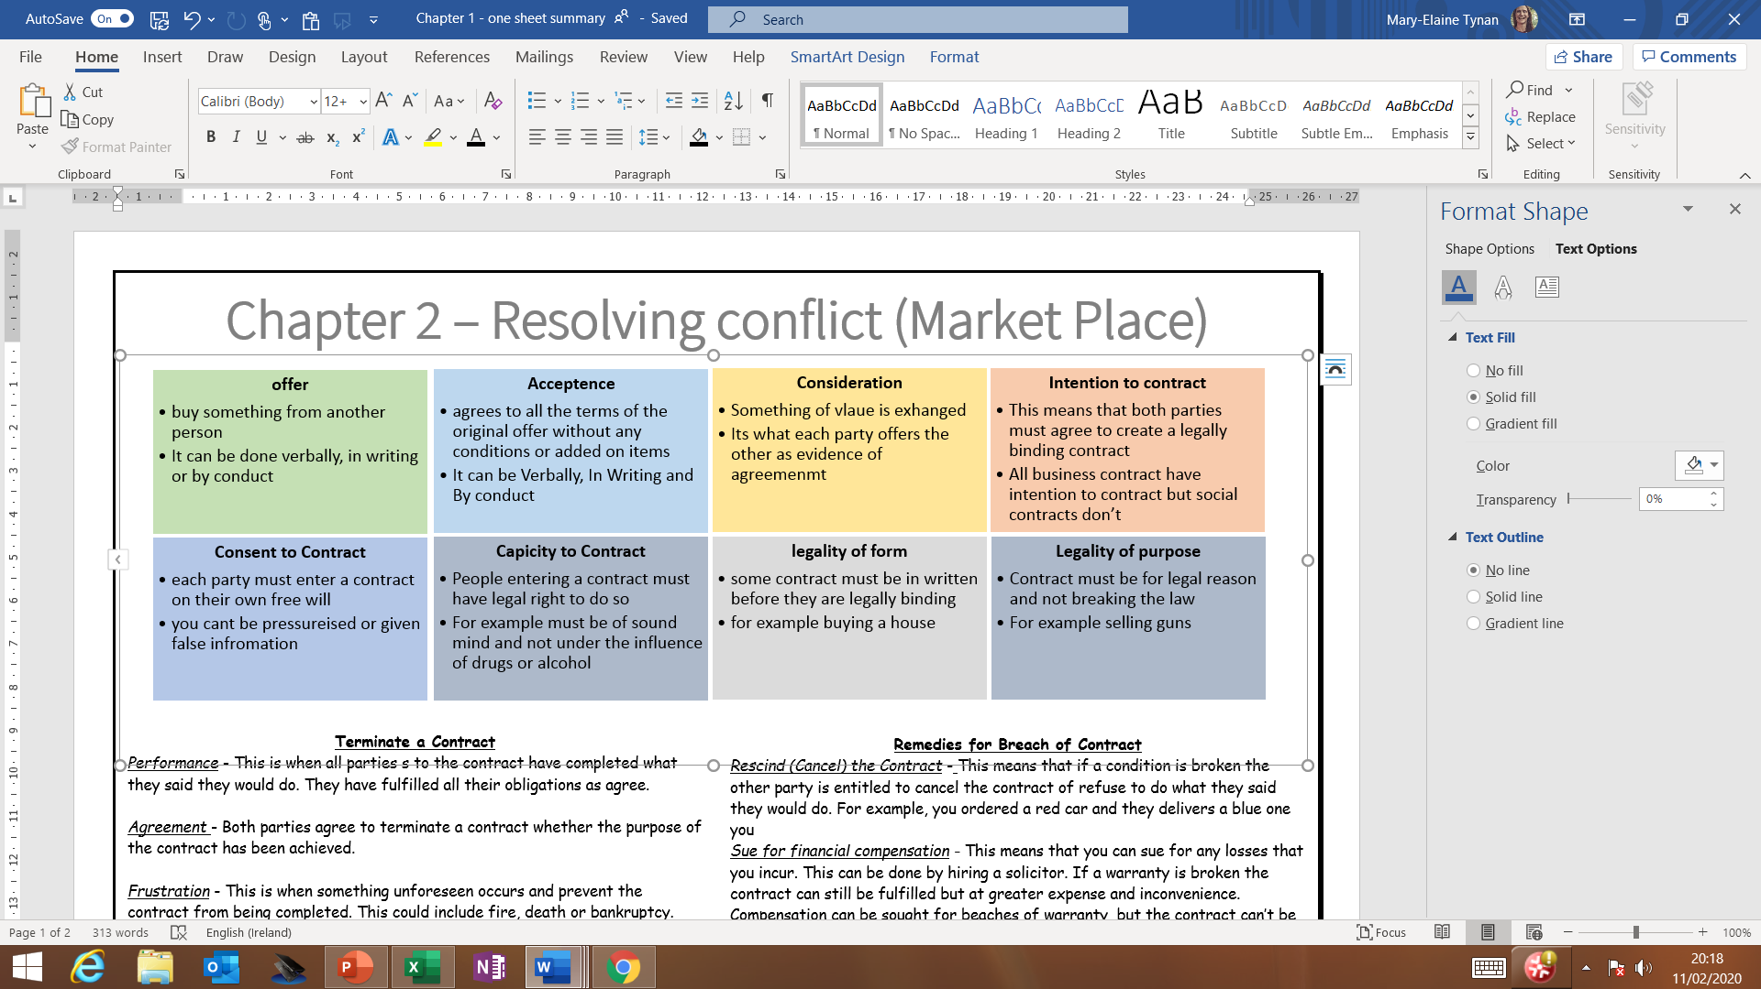

**Termination of a contract** - This means that the contract in no longer legally

binding and enforced by the law or courts

**Caveat emptor** - This means ‘Let the buyer beware’. When you are purchases items, a consumer must use common sense – if it is too good to be true it probably is

**Keywords**

**Contract**- This is a legally binding agreement between two or more people that is enforced in a court of law

**Law of Contract -** This set out the rule for providing a contract and when it

is terminated

**Remedies for Breach of Contract**

*Rescind (Cancel) the Contract* -This means that if a condition is broken the other party is entitled to cancel the contract of refuse to do what they said they would do. For example, you ordered a red car and they delivers a blue one you

*Sue for financial compensation -* This means that you can sue for any losses that you incur. This can be done by hiring a solicitor. If a warranty is broken the contract can still be fulfilled but at greater expense and inconvenience. Compensation can be sought for beaches of warranty, but the contract can’t be rescinded

*Seek Specific performance -* This means getting the court to order the other party to keep their side of the agreement

**Terminate a Contract**

*Performance* - This is when all parties s to the contract have completed what they said they would do. They have fulfilled all their obligations as agree.

*Agreement* - Both parties agree to terminate a contract whether the purpose of the contract has been achieved.

*Frustration* -This is when something unforeseen occurs and prevent the contract from being completed. This could include fire, death or bankruptcy.

*Breach of Contract -* This is when one of the parties to the contract breaks a condition. A condition is an important/essential element of a contract.